Primary Home Learning Resources and Ideas Summer Term.
Reminder from Come and See: Following the notification from Gavin Williamson, the Education Secretary to close Schools and Nurseries until further notice due to the COVID-19 virus. We are asking schools that wish to send Religious Education work home to download the relevant resources in the usual manner and make them available on their own school websites for parents to access. Under no circumstances must passwords to the Come and See website be given out.
The Way, The Truth and the Life: https://www.tere.org/ Support materials have been added for KS 1 and 2 for home learning tasks.
Music Resources:
https://www.bdes.org.uk/resources-for-prayer-and-learning.html - Dan Callow and Emily Clarke (from One Life Music) are producing a Weekly Worship and Song for use at home or at school. There is a link on the Birmingham Education website (see above) or alternatively, you can find them on YouTube if you search for ‘Weekly Worship and Song.’
Diocese of Leeds Schools Singing Programme launches daily singing sessions
Daily virtual singing sessions from the Diocese of Leeds Schools Singing Programme are now available at 2pm every weekday. Aimed at primary school children every session includes sacred music, RE and music curriculum learning, and lots of vocal fun and songs to keep children engaged in lifting their voices to God. They are led by the Diocese's expert Choral Directors, and sessions for younger and older children are also available.
Please subscribe to the YouTube channel, found at www.schoolssingingprogramme.org.uk - this is a wonderful tool to reach children and families across the country, so please share as widely as you can.
During the school closures Fischy Music are streaming an assembly every Monday morning at 11am https://www.youtube.com/user/Fischymusic
RE / Worship Resources:

https://missiontogether.org.uk/resources-by-month/calendar-may/
Resources to celebrate Mary and Pentecost can be found on this link.

https://www.looktohimandberadiant.com/
The website includes 30 ways to celebrate Mary.
https://www.looktohimandberadiant.com/2017/01/confirmation-door-pentecost-self.html Ideas for Pentecost linked with the Sacrament of Confirmation.
https://acnuk.org/resource/childs-bible-project/
The ACN Child’s Bible Project can be run in school or at home. ACN have made every effort to provide wide range of activities requiring only the natural creativity of children and items easily accessible at home or in school. The ACN Child’s Bible Project links in very well with the God Who Speaks, and the project has the support of the Bishops’ Conferences of England and Wales and of Scotland.
There are downloadable workbooks which include a short prayer and fun activity. Each day’s activity is linked to a video on YouTube. The videos are released each weekday at 10am on Twitter (@ACN_Schools, @ACN_Scotland, @ACNUK_NW); at the end of each week, the links are added into the workbooks, so you can catch up if you’ve missed anything.

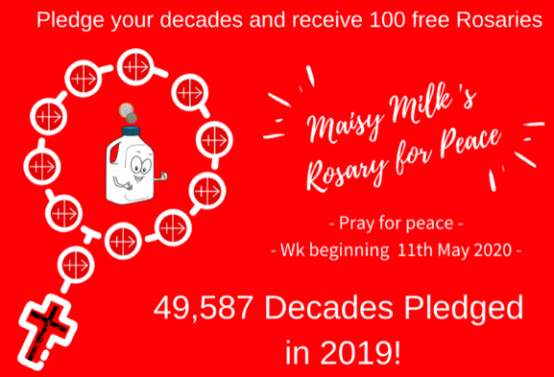
https://acnuk.org/resource/maisy-milk-rosary-for-peace/
Join our Social Media prayer initiative! Maisy Milk invites Schools and families to join the ACN Schools Team in praying one decade of the Rosary each day for one week in May, wk commencing 11th May 2020 (which includes the feast of Our Lady of Fatima). We offer our prayers for peace in our world and ask for Our Lady’s intercession and protection on behalf of Syrian families and Nigerian widows and orphans.

Every school that pledges their decades on the form below will get 100 free Rosaries for their school!

More details can be found from the link above.

https://cafod.org.uk/Education/Primary-teaching-resources/Home-learning-primary
CAFOD produce a resource pack for each week and previous packs are available.
https://cafod.org.uk/Education/Children-s-liturgy Liturgy produced each week.
https://www.natre.org.uk/about-natre/free-resources-for-you-and-your-pupils/

Website has links to RE home learning from a variety of providers, a list of video clip resources to aid independent learning and resources to support CPDF.
Feast Days:
https://www.catholicicing.com/ascension-of-jesus-crafts-for-kids/
Craft activities to remember the Ascension.
https://www.catholicicing.com/whos-ready-to-celebrate-pentecost/
Ideas to celebrate a Pentecost Party – Social distancing of course!
Dates in May:
Liturgical dates | Other dates
1st May St Joseph the Worker  3rd May Ss Philip and James  4th May Feast of English Martyrs  13th May Our Lady of Fatima  25th May St Bede  27th May St Augustine  31st May Visitation  Ascension Thursday The date of Easter changes every year and the Ascension is celebrated 40 days after Easter Sunday. | 8th May VE Day celebration  11th May World Migratory Birds Day  15th May International Day of Families  16th May International Day of Living Together in Peace  17th May World Telecommunication and Information Day.  18th May World Bee Day (20th)  21st May World day for Cultural Diversity  29th May International Day of UN Peacekeepers

RSE:
A message from McCrimmons publishers about Journey in Love:
This programme is currently being revised and will take account of the
latest DFE mandatory guidelines for September 2020. We are hoping to
have both the book and PowerPoint available for the autumn term.
https://www.tentenresources.co.uk/relationship-education/
Don’t forget TEN:TEN are offering free access to their collective worship resource at this time.

