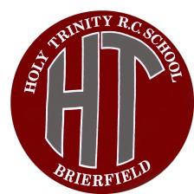 Holy Trinity RC Primary School
Halifax Road Brierfield,
Lancashire, BB9 5BL.

Head Teacher: Mrs M T Lyle BEd Hons NPQH

Please complete the form and email it to bursar@holytrinityrc.lancs.sch.uk as soon as possible:

Childs name: |  |  |  | Year group:

Details of parent who is a key worker:

Where parents are both key worker just complete for one
Name: |  | Job description:

Address of employer: (including postcode)

Employer contact number:

Standard care required

If the times you need don’t match the standard ones please write estimated drop off and pick up times between 9:30am-3:30pm in the box

Monday

Tuesday

Wednesday

Thursday

Friday

Wrap around care
 | Breakfast club (8-9am) |  | After school club (3:30-5pm)

Monday

Tuesday

Wednesday

Thursday

Friday

Lunch – please delete

School dinners / packed lunch

This must remain the same each day to ensure the correct food is ordered.

If your child shows any signs or symptoms of the corona virus then we would expect you to notify us immediately and to not bring them to school.

If Lancashire County Council were to provide weekend cover would you require this service?
Yes/No

If Lancashire County Council were to provide Easter holiday cover would you require this service?
Yes/No

