Maths
345,908 | 89,216 | 2,832,194 | 1,382.49 | 753.92

Pick one of the numbers above (pick a different number each day).
Then do each of these to the number…
- What is the value of the 9 digit in the number?
- Write the number in words.
- Double the number.
- Round it to the nearest 1,000
- Subtract 32 tens.
- Add 45 tenths.
Now try these:
- 288 ÷ 9 =
- Half of 4³ =
- The area of a rectangle with sides 40cm and 0.8 cm.
If you find the correct answers, what do you notice?

Maths
Negative Numbers
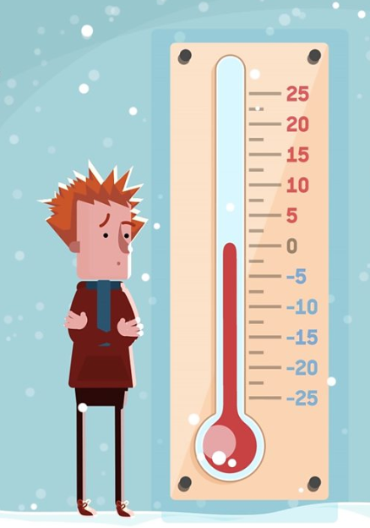
https://www.bbc.co.uk/bitesize/articles/z4kwjhv
Try the BBC lesson on Negative Numbers.
Can you complete the worksheet at the end?
English Challenge
Look at this poem called Ten things found in a Wizard's pocket by Ian McMillan
https://performapoem.lgfl.org.uk/public/poems/mcmillan_poem.pdf

Can you think of 10 precious things to place in a treasure chest. Write a poem similar to the one above. What would they really have in their treasure chests? A map to an island nobody knows? A silver cutlass sharp as a razor?
English
Watch chapter 2 and 3
Draw up a list of pros and cons about Long John Silver - if you were Jim, would you trust him? Do the same thing with reference to the ship’s crew.

English Challenge

You can read the whole book online here if you enjoyed learning about pirates.
http://www.literatureproject.com/treasure-island/

English
Watch video clip 1 and then read an extract from chapter 3 here (or on the sheet in the pack)
https://thingsthatmadeanimpression.wordpress.com/2013/06/01/excerpt-from-treasure-island-by-robert-louis-stevenson-black-spot/
Imagine you are a policeman who might have visited the inn to investigate the death of Billy Bones. What questions does he ask, and what is he told?

English Challenge
Look at the list of pirate language on this website.
https://www.theguardian.com/childrens-books-site/2015/sep/19/talk-like-a-pirate-day-an-essential-guide
or look at the attached sheet
Can you write some sentences using these phrases to speak like a pirate and impress your family members?
Maths Challenge 1
Shape Draw
Print out the clues from the sheet or download them here:
https://nrich.maths.org/content/id/10368/ShapeDraw.pdf
Can you draw the 1 shape the clues are describing?
Did you need to use all the clues?
Draw your own shape and write your own clues.
Key Text:
Treasure Island
Robert Louis Stevenson https://www.bbc.co.uk/teach/class-clips-video/english-ks2-treasure-island-home/zk2qnrd
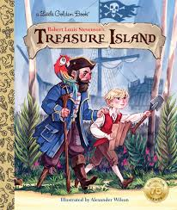

Home-Learning Ideas – UKS2 Theme: Pirates
When a learning activity has been completed, the box can be coloured in. When the all the boxes have been coloured – try the challenge boxes

E-Safety
Don't forget how to stay safe when you're using the internet at home.
Look at some of the help on…

https://www.thinkuknow.co.uk/

RE/PSHE
Make a poster for a pirates to encourage them to change their ways. You could include the following:
- Reasons for changing
- How they could use their skills instead
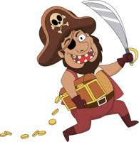
Computing
Try out this activity by clicking the instructions here. https://csunplugged.org/en/topics/error-detection-and-correction/unit-plan/parity-magic/
You don't even need a computer!
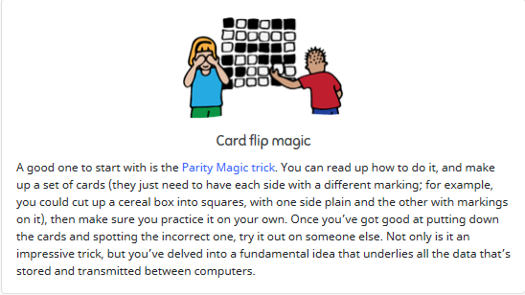

History
Look at this website, or read the sheet.
https://www.theguardian.com/childrens-books-site/2015/sep/19/talk-like-a-pirate-day-an-essential-guide
or look at the attached sheet
Several famous pirates are mentioned. You will find more at https://www.history.com/news/8-real-life-pirates-who-roved-the-high-seas Make yourself the following table and find out about 8 different pirates.
Who?  Name and Nickname (with explanation ) | What were they famous for? | Where did they pirate? | When did they pirate? | Interesting facts

Geography
Can you find treasure in your local area? Download the geocaching app and explore your local area.

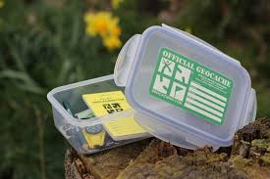
Draw a map to show where you have been and label it with a key.
Don't forget to wear gloves when handling a cache or clean hands immediately with antibacterial wipes.
Art and Design & Technology Challenge
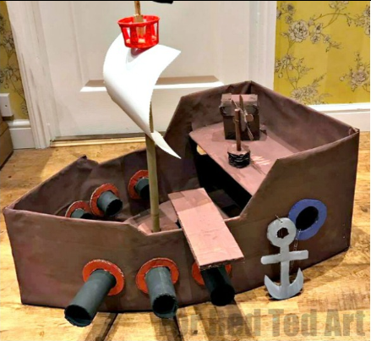
https://www.redtedart.com/diy-cardboard-pirate-boat/
Have a go at making a pirate ship of your own, click the link above for some instructions.
Art
https://www.youtube.com/watch?v=lF5-fhNDxU0

Watch Jonny Duddle draw a pirate and try to draw your own. Ask an adult to send it to him on Twitter @jonnyduddledum
Science
Float or Sink?
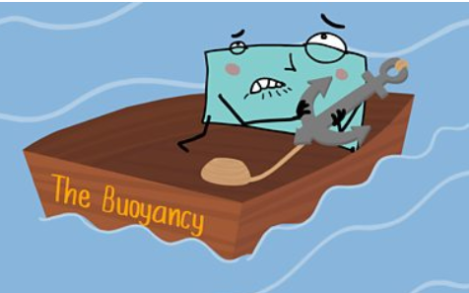 | Why do some things float and some  things sink? Click to find out…  https://www.bbc.co.uk/bitesize/topics/  zc89k7h/articles/zytqj6f
Challenge… make a boat that floats and holds 25 coins!
See the attached sheet… Whatever Floats Your Boat!
PE
Daily PE lessons with Joe Wicks

https://www.youtube.com/channel/UCAxW1XT0iEJo0TYlRfn6rYQ


