English
Before reading – find out the meaning of these words. Don't forget Word Hippo can helphttps://www.wordhippo.com/
ruining  barrel  hammock  pampered  galley  seafarers  barnacles | marooned  cannon  confined  motion  forbidden  merchant  Captain's quarters

Make a picture glossary by drawing a picture of all the nouns (things/people) mentioned.

English
Draw up a list of pros and cons about being a pirate – use the story extract to give you some ideas.

English

In the middle of your page, draw a picture of the narrator.
Make a list on either side of him.
List 1 – facts about his life (eg. his family, where he is, what you now about him, why he is not happy etc)

List 2 – why he wants to be a pirate

Maths Multiplication Challenge
Times Tables
Keep practising those multiplication tables…
Are you getting faster?
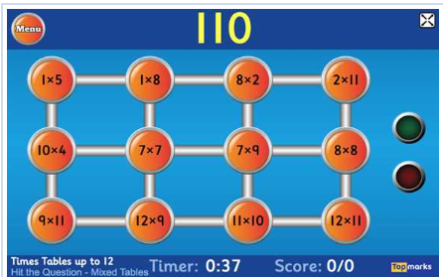
https://www.topmarks.co.uk/maths-games/7-11-years/times-tables
Each day, pick a times table fact and write as many related facts as you can… e.g. 6 x 8 = 48 so…
60 x 80 = 4800, 6 x 80 = 480, 0.6 x 8 = 4.8

English Challenge
The story is written like a diary. What do you think happens next? What problems arise? How do these get solved? How does the story end?
Write the rest of the diary to finish the story. Don't forget to include some pirate language when necessary.

Maths
28 | 484 | 4,824 | 42.8 | 832
Pick one of the numbers above (pick a different number each day).
Then do each of these to the number…
- What is the value of the 8 digit?
- Round to the nearest 100.
- Multiply by100.
- Half the number.
- Add 60
- Subtract 19
Now try these:
- 5 x 󠆣󠆣 = 60
- The number of months in a year.
- 󠆣 + 89 = 101
- The number of sides in two hexagons.
If you find the correct answers, what do you notice?
Maths Challenge
Flags & Shapes
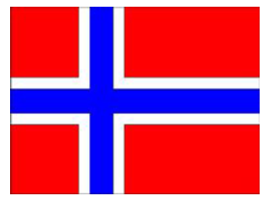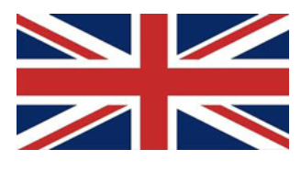
Look at the flags. Find out which country it's from.
https://nrich.maths.org/7749?utm_source=primary-map
What shapes can you see?
Are there parallel and perpendicular sides?
Are there any lines of symmetry?
If you need help to remember what parallel and perpendicular lines are, click here…
https://www.bbc.co.uk/bitesize/topics/zb6tyrd/articles/zp327hv
English Challenge

Make a list of all the 'pirate language' that the narrator uses. Write a glossary to explain the meaning (use the Talk Like a Pirate sheet to help).

Which are your favourite pirate phrases and why?

Key Text:
The Long Lost Secret Diary of the World's Worst Pirate
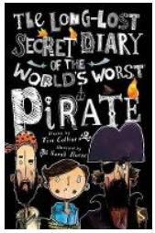
https://www.lovereading4kids.co.uk/book/14413/The-Long-Lost-Secret-Diary-of-the-Worlds-Worst-Pirate-by-Tim-Collins.html
or read the extract attached

Home-Learning Ideas – LKS2 Theme: Pirates
When a learning activity has been completed, the box can be coloured in. When the all the boxes have been coloured – try the challenge boxes

History
What can you find out about pirate ships? You could research:
- Typical style of ships
- The different parts of the ship
- What the different parts were used for
- The jobs that the pirates did on the ship
Draw a pirate ship and label the different parts or fill in the sheet
Which pirate job would you want to do and why?
There are some sheets in the pack to help you.
Find out about pirate flags then design your own.
RE/PSHE
Make a poster for a pirates to encourage them to change their ways. You could include the following:
- Reasons for changing
- How they could use their skills instead
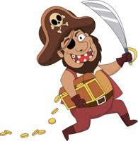
Science
The Best Boat
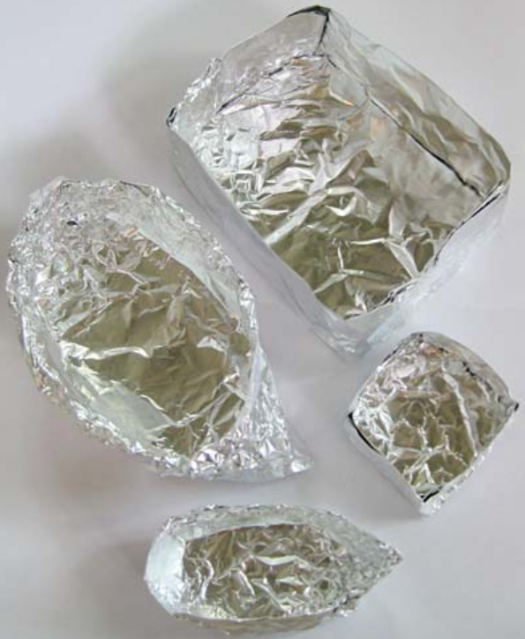 | Cut some squares from kitchen foil.  Make sure they are the same size.  Now make a boat from each one.  Make them all different.
Which is the best boat? Why?
Which can carry the most pennies?
Which boats leaked? Why?
Which boat tipped over? Why?
What advice would give someone making their own foil boat?
Geography
Can you find treasure in your local area? Download the geocaching app and explore your local area.

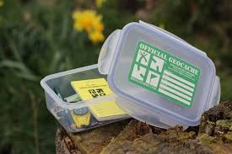
Draw a map to show where you have been and label it with a key.
Don't forget to wear gloves when handling a cache or clean hands immediately with antibacterial wipes.
Art and Design & Technology Challenge
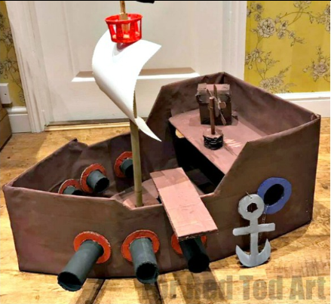
https://www.redtedart.com/diy-cardboard-pirate-boat/
Have a go at making a pirate ship of your own, click the link above for some instructions.

Art
https://www.youtube.com/watch?v=lF5-fhNDxU0

Watch Jonny Duddle draw a pirate and try to draw your own. Ask an adult to send it to him on Twitter @jonnyduddledum
PE
Daily PE lessons with Joe Wicks

https://www.youtube.com/channel/UCAxW1XT0iEJo0TYlRfn6rYQ

Computing
Practise your coding here with Lightbot!
https://lightbot.com/flash.html


E-Safety
Don't forget how to stay safe when you're using the internet at home.
Look at some of the help on…

https://www.thinkuknow.co.uk/

