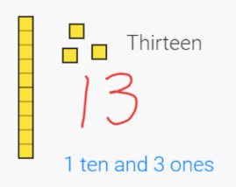
Maths Challenge 1

Triangle or No Triangle?
https://nrich.maths.org/14041
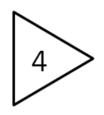Which shapes are triangle? Why?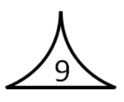
Use the attached sheet.
Maths
14 | 12 | 6 | 31 | 26
Each day, pick one of the numbers above, then…
- Say it
- Write it in words
- How many ones and how many tens?
- Find 1 more and 1 less
- Add 10
- Double it
- Is it even? Explain.

Maths
Counting in 10s and 1s
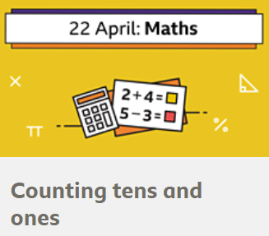 | Try out the BBC lesson on Counting in 10s and 1s.  https://www.bbc.co.uk/bitesize/articles/zvtppg8
Now try making different numbers… e.g. 23 | 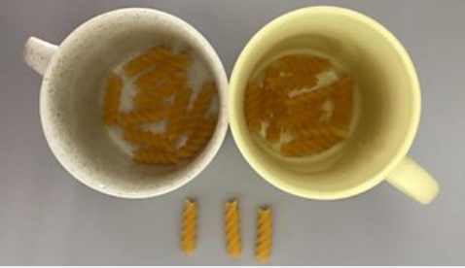

English Challenge
Write a postcard from Tilda to Jim. What could she tell him about life in Dull-on-Sea since the pirates left?

Can you write a postcard to someone you haven't seen for a while and post it to them?

Key Text:
The Pirates Next Door by Jonny Duddle https://www.youtube.com/watch?v=tPL_lVA95Yg
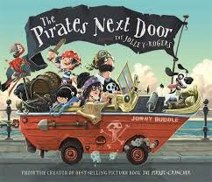
English
Create a grid to show the link between what the characters complained about and what the pirates left for them in their garden.
Character | Their complaint | Their present from the pirates
Mrs Divine | She moaned about their dirtiness, their old clothes and their scruffy hats. | Golden pirate hat.

English
Fold a piece of paper into 4 and choose 4 characters to draw and label.
What number do they live at? What else do you know about them? Can you use words from the text to help you?

Home-Learning Ideas – KS1 Theme: Pirates
When a learning activity has been completed, the box can be coloured in. When the all the boxes have been coloured – try the challenge boxes

Maths Challenge… Counting
Use the 100 square to practise counting.
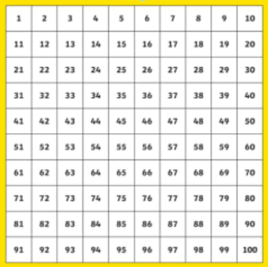 | Can you count forwards AND backwards?  Can you count in 2s?  Can you count in 10?  Can you start from any number?

Ask someone to cover a number on the 100 square.
Can you work out what number it is?

English Challenge
Look through the book again. How many skull and crossbones can you find hidden in the pictures? Do you think Tilda's mum is a secret pirate?

Computing
Turtle
Have fun moving the rocket, person… around the screen.
https://www.j2e.com/jit5#turtle
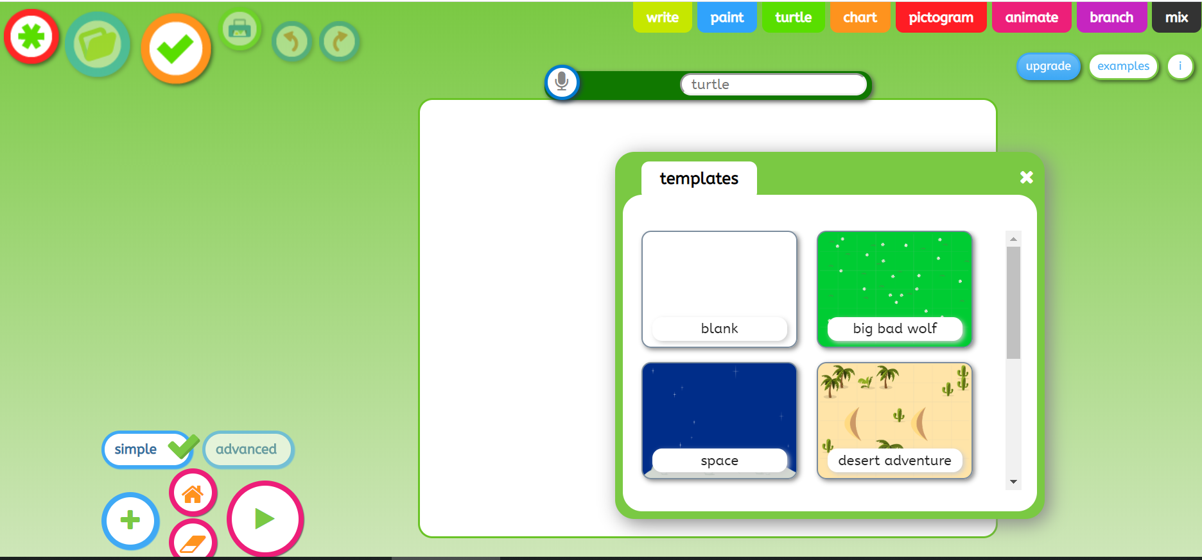
Can you turn the pen on and off?
Can you change the background?
Watch the instructions of the left.

RE/PSHE
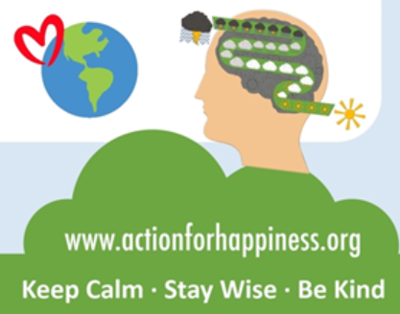
Trying doing some of these things to make you
and others feel better…
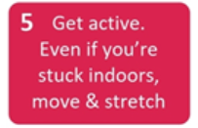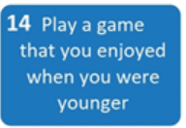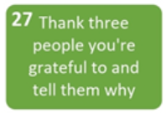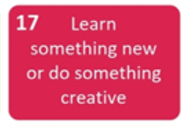

Science
Float or Sink?
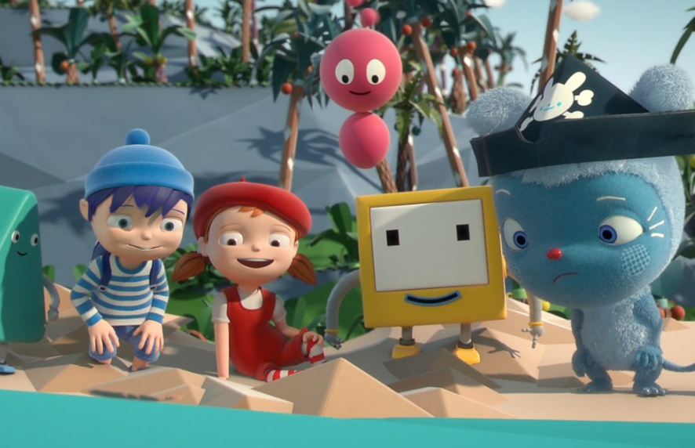 | Join Messy and friends to discover why things sink and float.  https://www.bbc.co.uk/cbeebies/watch/messy-goes-to-okido-why-do-things-sink-and-float
With an adult…
Can you find 5 things that you think will float?
Were you right?
What's the same and what's different about your things?
Geography
Can you find treasure in your local area? Download the geocaching app and explore your local area.

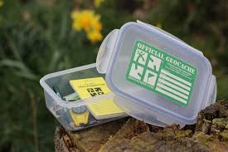
Draw a map to show where you have been and label it with a key.
Don't forget to wear gloves when handling a cache or clean hands immediately with antibacterial wipes.
Art and Design & Technology Challenge
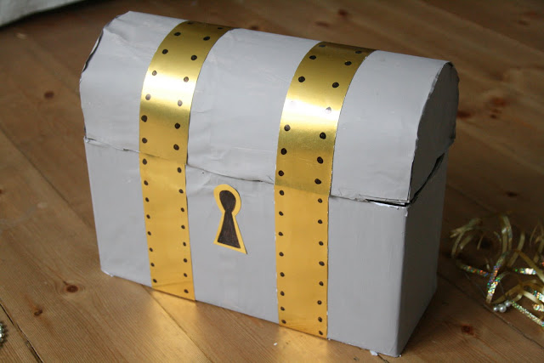
https://theimaginationtree.com/diy-treasure-chest/
Make a treasure chest from items in your recycling boxes. Make coins from the golden tinfoil from your Easter eggs and give them out to people in your household…or make them walk the plank!
Art
https://www.youtube.com/watch?v=lF5-fhNDxU0

Watch Jonny Duddle draw a pirate and try to draw your own. Ask an adult to send it to him on Twitter @jonnyduddledum
PE
Daily PE lessons with Joe Wicks

https://www.youtube.com/channel/UCAxW1XT0iEJo0TYlRfn6rYQ
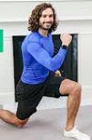
E-Safety
Don't forget how to stay safe when you're using the internet at home.
Look at some of the help on…

https://www.thinkuknow.co.uk/

