Maths
Fraction, Decimals and Percentages
Can you match them? Try here:
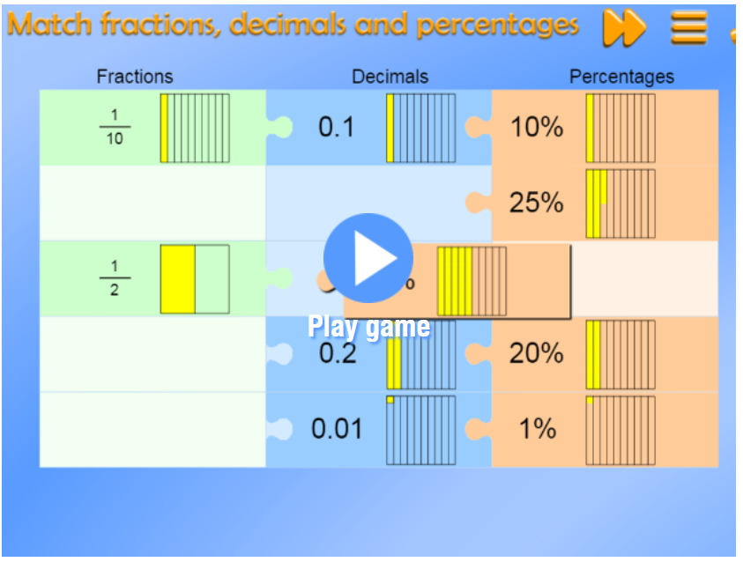
https://mathsframe.co.uk/en/resources/resource/120/match_fractions_decimals_and_percentages#.UCdcd2MsCEY

Maths Challenge 1
Route Product
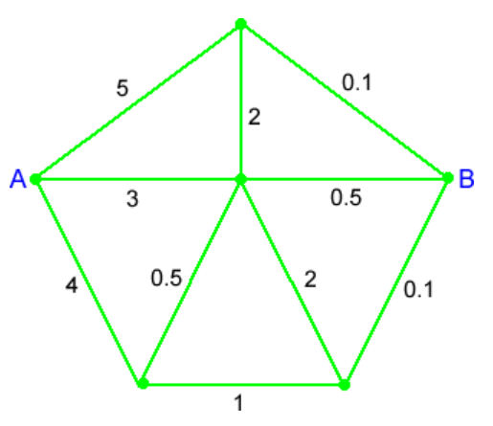
Try solving this problem at…
https://nrich.maths.org/5632?utm_source=primary-map
Maths
675 | 26,705 | 8,253.67 | 14.76 | 462.5

Pick one of the numbers above (pick a different number each day).
Then do each of these to the number…
- Write the number in words
- Divide it by 100
- Round it to the nearest 1000
- Identify the value of the 6 digit
- Double it
Now try these:
- The temperature in Preston is 1^{O}c. In Burnley it is 10^{O}c colder. What is the temperature in Burnley?
- 10² - 3² - 1³ =
- 489.3 - 488.4 =
- 60 x 150 =
If you find the correct answers, what do you notice?
English Challenge 1
Write a letter or a set of instructions to a supply teacher to give them guidance on how to make sure the class they are teaching behaves as they should.

English
What do all the poems have in common?
Which is your favourite and why?

English
Have a go at the questions and activities on the poetry sheet
Green – mild (getting warmed up)
Yellow – hot (time to think)
Purple – spicy (here's a challenge)

English Challenge 2
Choose one of the poems.
What is the 'story' in the poem?
Draw and write a comic strip which tells the story.

Key Text:
Read the following three poems by Allan Ahlberg
Please Mrs Butler
The Supply Teacher
It's a Puzzle

Home-Learning Ideas – Upper KS2 – The Ahlbergs
When a learning activity has been completed, the box can be coloured in. When the all the boxes have been coloured – try the challenge boxes

Maths Challenge 2
Times Tables
Keep practising those multiplication tables…
Each day, pick a times table fact and write as many related facts as you can… e.g. 4 x 3 = 12 so…
40 x 30 = 1200, 0.4 x 3 = 1.2, 120 ÷ 40 = 3
https://www.topmarks.co.uk/maths-games/7-11-years/times-tables

Science
NASA has a space telescope named The Hubble Space Telescope and it takes photographs from space everyday. Enter your birthday into this website form to see what was photographed on your birthday. Can you find out anything about what was photographed and share it with someone in your family? https://www.nasa.gov/content/goddard/what-did-hubble-see-on-your-birthday
PE
Daily PE lessons with Joe Wicks
https://www.youtube.com/channel/UCAxW1XT0iEJo0TYlRfn6rYQ
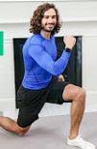
Art
Janet Ahlberg was famous for illustrating the books she and Allan produced together.
Illustrators are very good at drawing and have learnt lots of skills
Have a go at learning some new pencil skills following this lesson on shading.
https://www.youtube.com/watch?v=OezMavBqWXc

Now you can keep practising your shading. Why don't you try drawing a cup or a glass or a bowl? You could use the techniques you have just learnt.

E-Safety
Don't forget how to stay safe when you're using the internet at home.
Look at some of the help on…

https://www.thinkuknow.co.uk/

Art & DT Challenge
Watch this video that shows Allan and Jessica Ahlberg showing how they make a book with moveable parts.
Make your own moving picture to illustrate part of one of the poems.
https://www.youtube.com/watch?v=nxZAr0ffrVw
Try to include a slider mechanism, a pop-up
and lever.

Computing
Can you make a 'Pong Game' using Scratch?
Follow the tutorial and then make your own game.
https://scratch.mit.edu/projects/editor/?tutorial=pong
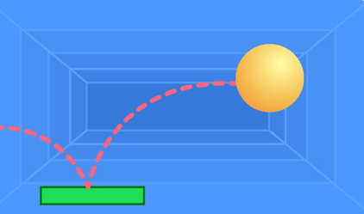
How complicated can you make it?
History
These Ahlberg poems are all set in schools.
What would it have been like if you were lucky enough to go to school 150 years ago?
Watch this video…
https://www.bbc.co.uk/programmes/p0115hdq
Make a list of the differences between schools now and then.
School in 1870 | School in 2020
Teachers used chalk and a blackboard | Teachers use an interactive board
What would it have been like to be at school if you were a Victorian child? Would you have enjoyed it?
Write a diary as if you were at a Victorian school. Describe your school, your day and what you felt about it.
RE / PSHE
Do you think the characters in the poems are kind?
How could they be kinder?
At this time, there are some very good examples of people being kind. Make a list of these.
Think about the sort of things people are doing at the moment that are not so kind. Design a poster, or make an information leaflet, that gives guidance on what people should be doing to be kind and why.

