Maths Challenge 1

Which Scripts?
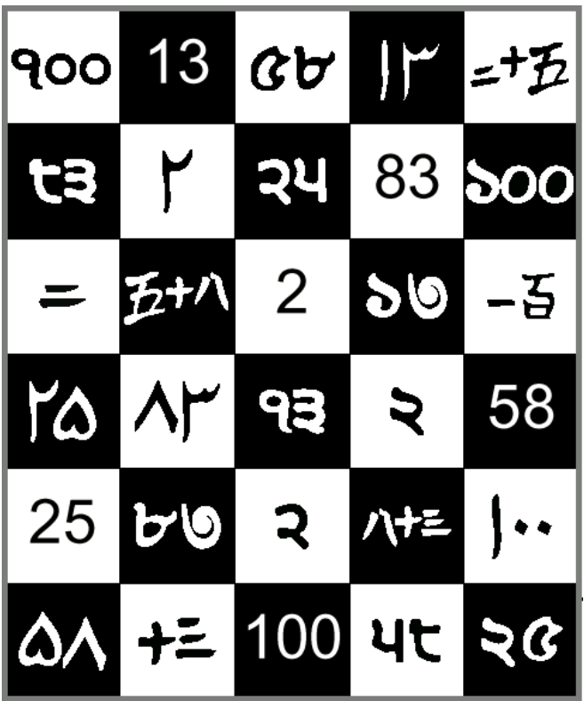
https://nrich.maths.org/774
Tricky…
Can you work out the 6 numbers that have been written in 5 different scripts / ways?
Clue 1: look for the numbers as we write them
Clue 2: spot the repeated symbols

Maths
Times Tables
Keep practising those multiplication tables…
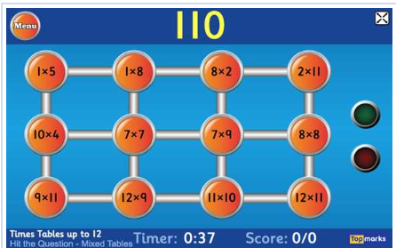
https://www.topmarks.co.uk/maths-games/7-11-years/times-tables
Each day, pick a times table fact and write as many related facts as you can… e.g. 3 x 8 = 24 so…
30 x 80 = 2400, 0.3 x 8 = 2.4, 3 x 80 = 24
Maths
84 | 345 | 428 | 4.6 | 23.4

Pick one of the numbers above (pick a different number each day).
Then do each of these to the number…
- Write the number in words
- Multiply it by 10
- Halve it
- Round it to the nearest 10
- Identify the value of the 4 digit
- Double it
Now try these:
- 10 x 4 =
- 84 - 52 =
- The number of quarters in a whole =
- The number of hours in a day =
- The next number in this sequence 7, 10, 13, …
If you find the correct answers, what do you notice?

Maths Challenge 2
Equivalent Fractions
Fractions with the same value as another fraction are equivalent. For example: 4/8, 5/10, 8/16 are all equivalent fractions and all are equal to ½.
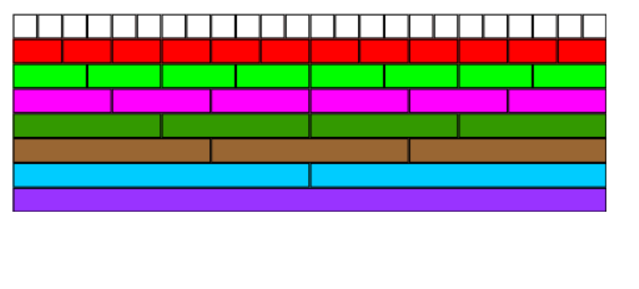
Try this activity to see if you can find equivalent fractions.
https://nrich.maths.org/4519
English
Use a thesaurus (you could use Word Hippo online: ( https://www.wordhippo.com ) to find different synonyms for 'burglar'

English
Listen to/read the story again and make a list of all the things Burglar Bill steals

English
Make a time-table to show Burglar Bill's typical day at the beginning of the book. Then do another to show what a typical day might be by the end of the book. Draw a picture and write a description

Morning | During the Day
Supper Time | During the Night

English Challenge
Describe your favourite character – make sure you include
Name  Appearance  Characteristics | Why you like this character more than the others

Key Text:
Burglar Bill by Janet and Allan Ahlberg
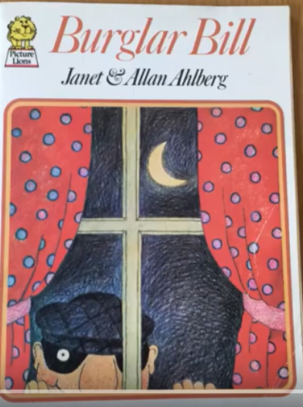
https://www.youtube.com/watch?v=kRoWYz34uss

Home-Learning Ideas – LKS2 -Theme: Amazing Authors - Ahlbergs
When a learning activity has been completed, the box can be coloured in. When the all the boxes have been coloured – try the challenge boxes

English Challenge 2
Janet and Allan Ahlberg have written many books and poems. Make a list of as many as you can find.
Read some of them and then pick one to recommend to a friend. Include the following:
Title
Author and Illustrator
Summary of what it is about
Why you would recommend it

English Challenge 1
Write your own story based on Burglar Bill you could:
- Change one or more of the characters
- You could change some of the things that are stolen
- You could change the things he likes to eat
- You could change what he does to entertain the baby
You could call your story…
Burglar Brian or Stealing Sally or Thieving Theo

PE
Daily PE lessons with Joe Wicks
https://www.youtube.com/channel/UCAxW1XT0iEJo0TYlRfn6rYQ


History
Imagine you were a young child 70 years ago in the 1950s. What toys were popular then? Have a look at this website and choose a toy that you would have fun playing with now. Draw a picture of it and describe how children used it to have fun back in the 1950s
https://www.retrowaste.com/1950s/toys-in-the-1950s/

E-Safety
Don't forget how to stay safe when you're using the internet at home.
Look at some of the help on…

https://www.thinkuknow.co.uk/

Science
NASA has a space telescope named The Hubble Space Telescope and it takes photographs from space everyday. Enter your birthday into this website form to see what was photographed on your birthday. Can you find out anything about what was photographed and share it with someone in your family? https://www.nasa.gov/content/goddard/what-did-hubble-see-on-your-birthday

Art & DT Challenge
Watch this video that shows Allan and Jessica Ahlberg showing how they make a book with moveable parts. Try to make your own moving picture book.
https://www.youtube.com/watch?v=nxZAr0ffrVw
Try to use a pop up…
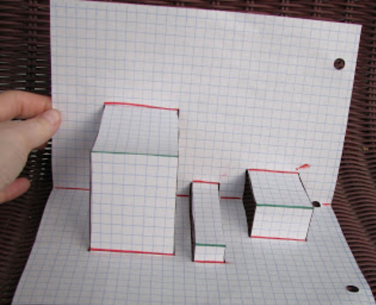
There are examples here:
https://www.extremepapercrafting.com/p/pop-up-lessons-how-to-books.html

Art
Learn how to draw a cartoon character
https://www.youtube.com/watch?v=Zvel0Tl5ouE
Can you adapt this now and make some illustrations for your story?
Computing
Make your name come to life…
Use Scratch and follow the instruction
https://scratch.mit.edu/projects/editor/?tutorial=name
RE
Draw a picture of Burglar Bill at the beginning of the story
Make two lists
Burglar Bill's good qualities | Burglar Bill's not so good qualities

Many religious leaders teach that it is wrong to steal. Why do you think this is?
Describe how Burglar Bill has become a better person by the end of the story

