When you add two numbers, you can change the order and the answer is the same.
When you cut a square in half you get a triangle
Maths Challenge 1
Always, Sometimes or Never true? Convince me!
Key Text:
Each Peach, Pear, Plum by
Janet and Allan Ahlberg
https://www.youtube.com/watch?v=kIAVjQEs5oI
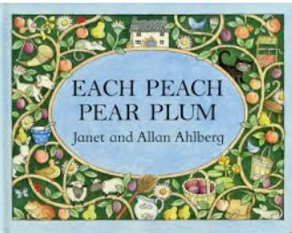
Maths
Shark Numbers
Play the shark numbers game. Can you identify the number represented?
Don't let the sharks get you!
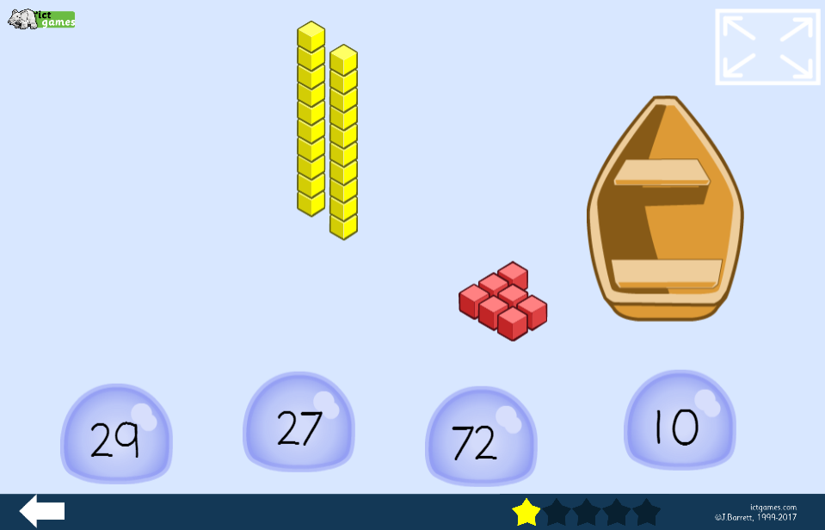
(The answer to this is 27!)
http://www.ictgames.com/sharkNumbers/mobile/index.html

English Challenge
How many other characters from rhymes do you know?
How many other characters from traditional tales do you know?
Can you make up some of your own rhymes for the story using these?
Eg. Tom Thumb flies a kite, I spy Snow White
Humpty Dumpty in the mud, I spy Red Riding Hood
Yr 2s, you might be able to put your rhymes together to make a new story

English
Sort the characters into two lists
Characters from Rhymes | Characters from Stories
- Write out the rhyme Jack and Jill
- Can you find the rhyming words?
- What is a pail?
- How many words can you find to rhyme with pail?
- Choose another rhyme
- Find out the meaning of any words you don't know
- Draw some illustrations to go with the rhyme

English
Draw all the characters in the book with their names. Do this in the order they appear.
What do you know about each of the characters? Write some information next to each one. Find out about the characters you do not know.

Maths
Counting
Use the 100 square to practise counting.
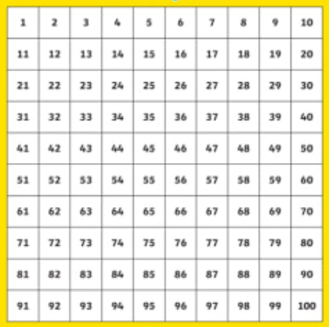
Can you count forwards AND backwards?
Can you start from any number?
How far can you count in 2s… 2, 4, 6? What pattern do you notice?
How far can you count in 5s… 5, 10, 15? What pattern do you notice?
Home-Learning Ideas – KS1 Theme: Amazing Authors – The Ahlbergs
When a learning activity has been completed, the box can be coloured in. When the all the boxes have been coloured – try the challenge boxes

Maths Challenge 2
How many Animals?
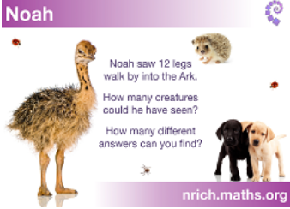
Sheet attached… https://nrich.maths.org/7210&part=
What if Noah saw 16 legs?
How many creatures could he have seen?
Art and Design & Technology Challenge
To do with a grown up or an older brother or sister
Watch this video that shows Allan and Jessica Ahlberg showing how they make a book with moveable parts. Try to make your own moving picture book.
https://www.youtube.com/watch?v=nxZAr0ffrVw
Make a slider. Will it go side to side or up and down?
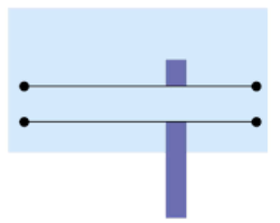
Art
Still life drawing.
Get a piece of fruit or a vegetable and put in front of you.
Look closely – what do you notice about the shape, the colours, the texture (is it smooth, bumpy etc?)
Draw the outline and then colour in with as much detail as possible
You could also have a go at some cartoon drawings of fruit
https://www.youtube.com/watch?v=QY5frjliNAw
Parents/carers, you will probably want to mute the film
Science
When you are on your daily walk or in your take note of the changes. Blossom trees are looking very different this week. Some have lost a lot of their blossom and some still have some on.
http://www.treetoolsforschools.org.uk/activities/labelling/?act=lbl_tree_blossom_and_flowers_ID&id=0&col=D2232A&light=0&lcol=891C23&title=Tree%20blossom%20and%20flowers%20ID
Try this labelling activity. Find out the names of flowering trees in your local area.
History
Who was William Shakespeare? KS1 Bitesize.
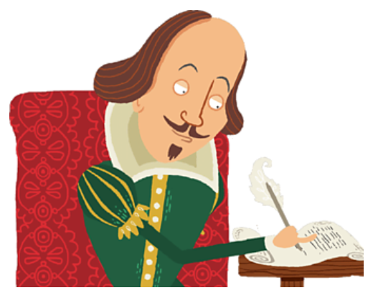
https://www.bbc.co.uk/bitesize/topics/z7d7gwx/articles/zrxwy9q
Watch and enjoy two of his plays on iPlayer, The Tempest and A Midsummer Night's Dream.
https://www.bbc.co.uk/iplayer/episodes/b0bl2khw/cbeebies-presents

RE/PSHE
Cinderella is a kind character. What makes her kind?
How many other good characters do you know? Make a list and say what makes them a good character.

Some people are being extra kind at the moment. I know about an elderly person living alone who found a picture left for her. A child living nearby had drawn it to cheer her up – and it did.
What can you do to be kind? Choose a kind thing to do and ask a grown up in your house to help you do it. You must ask a grown up to make sure you stay safe.

PE
Daily PE lessons with Joe Wicks

https://www.youtube.com/channel/UCAxW1XT0iEJo0TYlRfn6rYQ
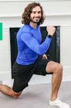

E-Safety
Don't forget how to stay safe when you're using the internet at home.
Look at some of the help on…

https://www.thinkuknow.co.uk/

Computing
Can you programme the robot to deliver the letters?
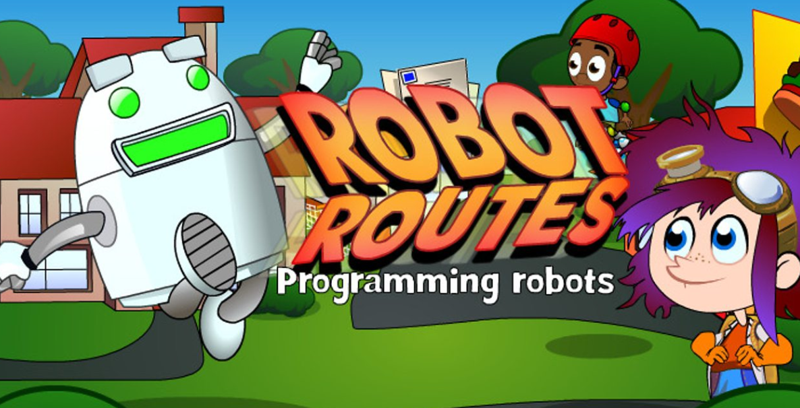
Click the picture to go to the game.

