
Holy Trinity RC Primary School: EYFS Long Term Plan 2026-27
‘To go Forward Together in Christ, Respecting our Neighbour and Striving for Excellence’.

 |  | Autumn 1  Marvellous Me  (Ourselves) |  | Autumn 2  Once Upon a Time  (Traditional Tales & Nursery Rhymes) |  | Spring 1  Yummy, Scrummy!  (Food) |  |  | Spring 2  Roots, Shoot and Muddy Boots!  (Change & Growth) |  | Summer 1  Into the Woods  (Bears) | Summer 2  Fantasy & Adventure  (Journeys)
Prime Areas

Communication & Language

Pre-School |  | Talk to an adult.  Listen to longer stories and remembering much of what happens.  Paying attention to more than one thing at a time. |  | Talk to others.  Use a wider range of vocabulary.  Understanding questions or instructions that have two parts.  Playing with songs, sounds and rhymes. |  | Understanding ‘why’ questions.  Singing a large repertoire of songs.  Use longer sentences.  Listen to sounds all around us. |  |  | Knowing many rhymes and talking about familiar books and telling longer stories.  Developing pronunciation of sounds. |  | Express a point of view and debating.  Starting conversations with adults and friends, continuing it for many turns. | Use talk to organise selves and play.  Describe what we hear, see and feel.
Time to Talk- Talk Boost Intervention
In the Moment Planning

At the end of Pre-School, children should be able to:
Enjoy listening to longer stories and remember what has happened. Pay attention to more than one thing at a time and use a wider range of vocabulary. Understand a question or instruction that has two parts, such as ‘get your coat and wait at the door’. Understand ‘why’ questions like ‘why do you think the caterpillar got so fat?’. Sing a large repertoire of songs, know many rhymes, be able to talk about familiar books and be able to tell a long story. Develop communication but may continue to have problems with irregular tenses and plurals such as ‘runned’ for ‘ran’. Develop pronunciation but may have problems saying some sounds; r, j, ch, th and sh and multisyllabic words. Use longer sentences of four to six words. Be able to express a view point and debate when they disagree with an adult or friend, using words as well as actions. Start a conversation with an adult or a friend and continue it for many turns and use talk to organise themselves and their play ‘lets go on a bus… you sit there… I’ll be the driver’.
Reception |  | Understand how to listen carefully and why listening is important.  Engage in story times, rhymes, and songs.  Maintain attention in whole class/groups.  Follow 1 step instructions.  Understand ‘why’ questions.  Use sentences 4-6 words.  Use talk to organise play. |  | Listen in familiar & new situations.  Engage in story times.  Maintain attention in new situations.  Ask questions to find out more and to check they understand what has been said to them.  Follow instructions with 2 parts in a familiar situation.  Start a conversation with peers and familiar adults and continue for many turns.  Develop social phrases. |  | Listen attentively in a range of situations.  Maintain attention during appropriate activity.  Engage in non-fiction books.  Consider the listener and take turns.  Use talk to organise/stand for something else in play.  Begin to use past tense.  Begin to recount past events. |  |  | Understand why listening is important.  Maintain attention in different contexts.  Use talk to help work out problems and organise thinking and activities explain how things work and why they might happen.  Ask questions to find out more and check understanding.  Articulate their ideas and thoughts in well-formed sentences.  Listen to and talk about selected non-fiction to develop a deep familiarity with new knowledge and vocabulary.  Begin to connect one idea or action to another using a range of connectives.  Describe events in some detail. |  | Listen and understand instructions while busy with another task.  Maintain activity while listening.  Understand how, why, where questions.  Describe events in some detail.  Express ideas about feelings and experiences.  Articulate their ideas and thoughts in well-formed sentences.  Use language to reason. | Listen and respond with relevant questions, comments, or actions.  Attend to others in play.  Make comments and clarify thinking with questions.  Retell the story once they have developed a deep familiarity with the text; some as exact repetition and some in their own words.  Speak in well-formed sentences with some detail.  Use new vocabulary in different contexts.  Use past, present, and future tenses in conversation with peers and adults. Use conjunctions to extend and articulate their ideas.
Learn and use new vocabulary in different contexts. Learn new vocabulary throughout the day. Listen carefully to rhymes and songs, paying attention to how they sound. Learn rhymes, poems, and songs. Listen to and talk about stories to build familiarity and understanding.

WELCOMM Interventions
Early Learning Goals:
Listening, Attention and Understanding- Listen attentively and respond to what they hear with relevant questions, comments and actions when being read to and during whole class discussions and small group interactions. Make comments about what they have heard and ask questions to clarify their understanding. Hold conversation when engaged in back-and-forth exchanges with their teachers and peers.
Speaking- Participate in small group, class and one-to-one discussions, offering their own ideas, using recently introduced vocabulary. Offer explanations for why things might happen, making use of recently introduced vocabulary from stories, non-fiction, rhymes and poems when appropriate. Express their ideas and feelings about their experiences using full sentences, including use of past, present and future tenses and making use of conjunctions, with modelling and support from their teacher.
Personal, Social and Emotional Development

Pre-School |  | Select and use activities and resources with help when needed.  Develop a sense of responsibility and membership of a community. |  | Become outgoing with unfamiliar people in the safe context of their setting.  Show more confidence in new social situations. |  |  | Play with one or more children, extending and elaborating play ideas.  Find solutions to conflicts and rivalries. |  | Increasingly follow rules and understand why they are important.  Remembering rules without needing an adult to remind them. |  | Develop appropriate ways of being assertive.  Talk with others to solve conflicts.  Talk about feelings using words like happy, sad and angry. | Understand gradually how others might be feeling.  Being increasingly independent in meeting own care needs.  Make healthy choices about food, drink, activities and tooth brushing.
Lancashire Teeth Brushing
In the Moment Planning

At the end of Pre-School, children should be able to:
Select and use activities and resources with help when needed. Develop a sense of responsibility and membership of a community. Become more outgoing with unfamiliar people, in the safe context of their setting and show more confidence in new social situations. Play with one or more other children, extending and elaborating play ideas. Find solutions to conflicts and rivalries. Increasingly follow rules and understand why they are important, remember rules without needing an adult to remind them and develop appropriate ways of being assertive. Talk with others to solve conflicts and talk about feelings and use words like ‘happy’, ‘sad’ or ‘angry’. Understand gradually how others might be feeling and be increasingly independent in meeting own care needs and make healthy choices about food, drink, activity and toothbrushing.
Reception |  | Can talk about feelings.  Increasing follow rules.  Aware of likes and dislikes.  Independently organise belongings in the morning.  Manage personal hygiene.  Build constructive and respectful relationships. |  | Can begin to express feelings and consider the perspectives of others.  Begin to take turns and share resources.  Independently choose where to play.  Continue to build constructive and respectful relationships. |  |  | Show pride in achievements.  Understand behavioural expectations of the setting.  Explain right from wrong and try to behave accordingly.  Manage own needs.  Identify kindness.  Seek others to share activities and experiences. |  | Make choices and can communicate what they need.  Begin to show persistence when faced with challenges.  Keep play going by co-operating, listening, speaking and explaining.  Reflect on the work of others and self-evaluate their own work. |  | Begin to know that children think and respond in different ways to them.  Talk about their own abilities positively.  Confident to try new activities.  Show resilience and perseverance. | Identify and moderate own feelings.  See themselves as a unique and valued individual.  Seek out a challenge and enjoy the process.  Show sensitivity to the needs and feelings of others.
Early Learning Goals:
Self-Regulation- Show an understanding of their own feelings and those of others and begin to regulate their behaviour accordingly. Set and work towards simple goals, being able to wait for what they want and control their immediate impulses when appropriate. Given focused attention to what the teacher says, responding appropriately even when engaged in activity, and show an ability to follow instructions involving several ideas or actions.
Managing Self- Be confident to try new activities and show independence, resilience and perseverance in the face of challenge. Explain the reasons for rules, know right from wrong and try to behave accordingly. Manage their own basic hygiene and personal needs, including dressing, going to the toilet and understanding the importance of healthy food choices.
Building Relationships- work and play cooperatively and take turns with others. Form positive attachments to adults and friendships with peers. Show sensitivity to their own and to others’ needs.
Physical Development

Pre-School |  | Continually develop movement, balance, riding and ball skills.  Go up steps and climbing apparatus using alternate feet. |  | Skipping, hopping, standing on one leg and holding poses for games such as musical statues.  Use large muscle movements to wave streamers and to paint and mark make.  Increasingly be able to use and remember sequences and patterns of movement related to music and rhythm. |  |  | Begin to take part in some group activities that are made up or in a team.  Match physical skills to tasks and activities  Collaborate with others to manage larger items.  Use music and movement to explore space and how our bodies react to exercise.  Healthy eating. |  | Choose the right resources to carry out plans.  Use on-handed tools and equipment.  Senses walks, looking and listening to the world around us. |  | Use a pencil with comfortable grip with good control.  Show preference for dominant hand. |  |  | Become increasingly independent when dressing and undressing.  Develop the ability to meet own care needs.
Wake & Shake
Cosmic Yoga
In the Moment Planning

At the end of Pre-School, children should be able to:
Continue to develop movement, balancing, riding, and ball skills, go up steps and stairs or climb up apparatus using alternate feet. Skip, hop and stand on one leg, use large muscle movements to wave flags, paint and make marks. Start talking part in some group activities which they make up for themselves or in teams. Increasingly be able to use and remember sequences and patterns of movement which are related to music and rhythm. Match their developing physical skills to tasks and activities in the setting. Choose the right resources to carry out their own plan. Collaborate with others to manage large items, such as moving a long plank safely. Use one-handed tools and equipment, for example, making snips in paper with scissors. Use a comfortable grip with good control when holding pens and pencils, show a preference for a dominant hand and be increasingly independent as they get dressed and undressed, for example, putting coats on and doing up zips.
Reception |  | Further develop the skills needed to manage the school day successfully: line up, mealtimes and personal hygiene.  Further develop fine motor skills: pencil grip, using scissors, paintbrushes etc. |  | Revise and refine the fundamental movement skills already acquired: rolling, crawling, walking, jumping, running, hopping, skipping & climbing.  Develop letter formation following RRP programme. |  |  | Further develop and refine a range of ball skills including throwing, catching, kicking, passing, batting, and aiming.  Develop confidence, competence, precision, and accuracy when engaging in activities that involve a ball.  Further develop letter formation following RRP programme. |  | Know and talk about different factors that support overall health and wellbeing: regular physical activity, healthy eating, toothbrushing, sensible amounts of screen time and having a good sleep routine.  Further develop letter formation following RRP programme. |  | Combine different movements with ease and fluency.  Develop the foundations of a handwriting style which is fast, accurate and efficient. |  |  | Confidently and safely use a range of large and small apparatus indoors and outside, alone and in a group.  Develop the foundations of a handwriting style which is fast, accurate and efficient.
Early Learning Goals:
Gross Motor Skills- negotiate space and obstacles safely, with consideration for themselves and others. Demonstrate strength, balance and coordination when playing. Move energetically, such as running, jumping, dancing, hopping, skipping and climbing.
Fine Motor Skills- hold a pencil effectively in preparation for fluent writing- using the tripod grip in almost all cases. Use a range of small tolls, including scissors, paint brushes and cutlery. Begin to show accuracy and care when drawing.
Literacy

Pre-School |  | 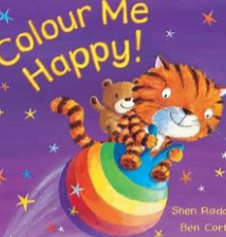  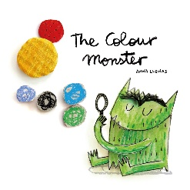  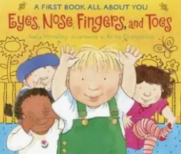  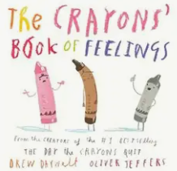  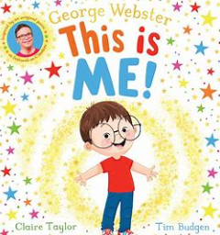 |  | 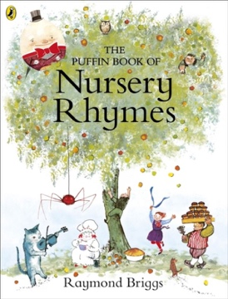 |  |  | 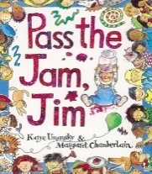  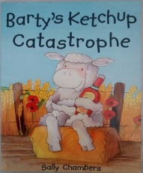  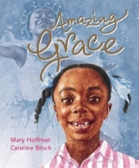  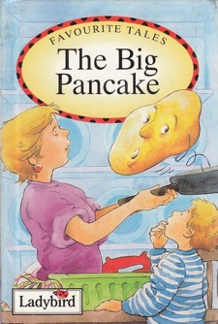 |  | 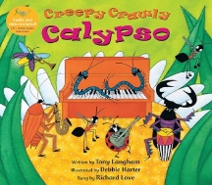  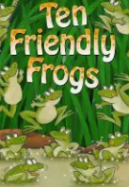  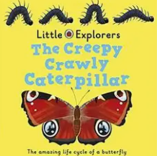  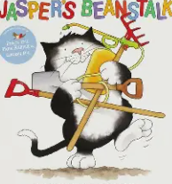 |  | 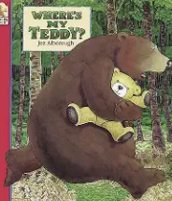  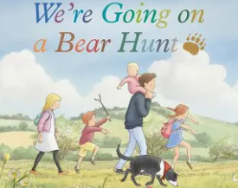 |  |  | 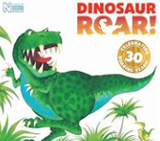  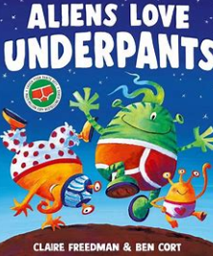  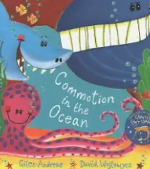
Phase 1 Phonics |  |  |  |  |  |  |  |  |  |  |  |  |  | Phase 2 Phonics- SATPIN  (picture books to take home)
At the end of Pre-School, children should be able to:
Understand the five key concepts about print: print has meaning, print can have different purposes, we read English text from left to right and top to bottom, the names of the different parts of a book and page sequencing. Develop their phonological awareness so that they can spot and suggest rhymes, count or clap syllables in a word and recognise words with the same initial sound such as money and mother. Engage in extended conversations about stories, learning new vocabulary. Use some of their print and letter knowledge in their early writing, for example, writing a pretend shopping list that starts at the top of the page. Write some or all of their name and write some letters accurately.
Reception |  | 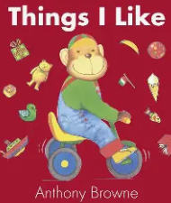  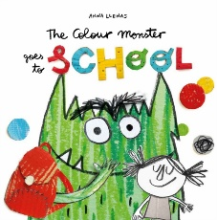  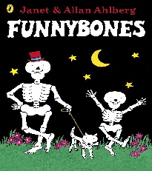  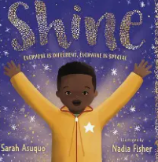  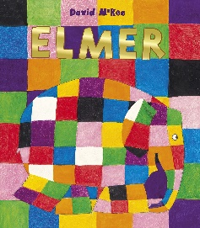  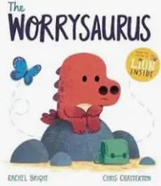 |  | 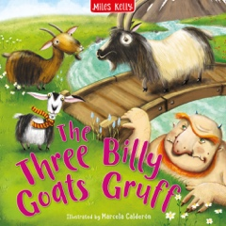  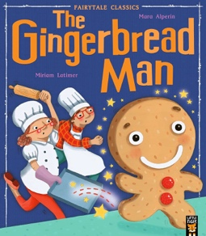  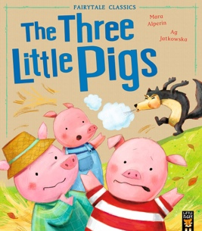  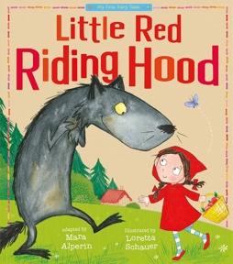 |  |  | 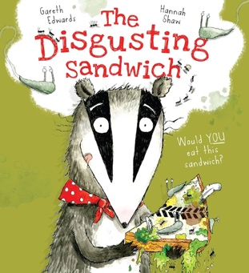  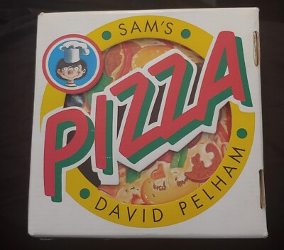  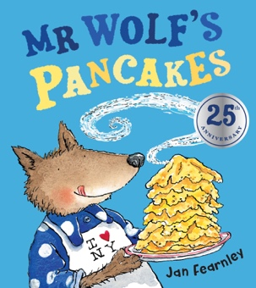  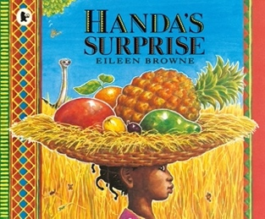 |  | 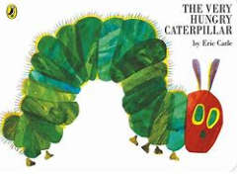  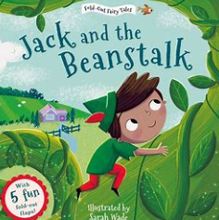  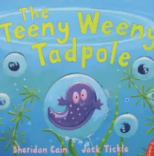  Non-fiction texts about lifecycles and minibeasts. |  | 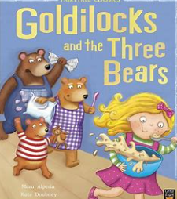  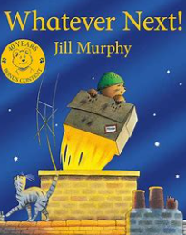 |  |  | 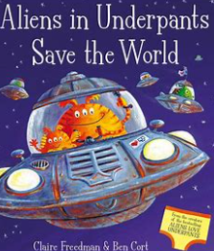  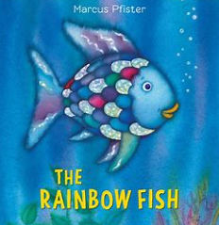  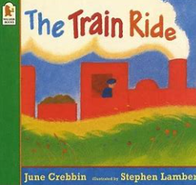  Dinosaur Poetry  Space Non-Fiction Books
 |  | Phase 1 phonics (2 week recap)  Phase 2 phonics |  | Phase 2 phonics |  |  | Phase 3 phonics |  | Phase 3 phonics |  | Phase 3 phonics |  |  | Phase 4 phonics
Early Learning Goals:
Comprehension- demonstrate understanding of what has been read to them by retelling stories and narratives using their own words and recently introduced vocabulary. Anticipate-where appropriate- key events in stories. Use and understand recently introduced vocabulary during discussions about stories, non-fiction, rhymes and poems and during role-play.
Word Reading- say a sound for each letter in the alphabet and at least 10 digraphs. Read words consistent with their phonic knowledge by sound-blending. Read aloud simple sentences and books that are consistent with their phonic knowledge, including some common exception words.
Writing- write recognisable letters, most of which are correctly formed. Spell words by identifying sounds in them and representing the sounds with a letter or letters. Write simple phrases and sentences that can be read by others.
Maths

Pre-School |  | Master the Curriculum:  Colours  Matching  Sorting |  | Master the Curriculum:  Number 1  Number 2  Pattern |  |  | Master the Curriculum:  Number 3  Number 4  Number 5 |  | Master the Curriculum:  Number 6  Height & Length  Mass  Capacity |  | Master the Curriculum:  Sequencing  Positional Language  More/Fewer Than  2D Shapes  3D Shapes |  |  | Master the Curriculum:  Number Composition  What Comes After?  What Comes Before?  Numbers to 5
In the Moment Planning

At the end of Pre-School, children should be able to:
Develop fast recognition of up to 3 objects, without having to count them individually (subitising), recite numbers past 5, say one number for each item in order, know that the last number reached when counting a small set of objects tells you how many there are in total (cardinal principle), show finger numbers up to 5 and link numerals and amounts up to 5. Experiment with their own symbols and marks as well as numerals, solve real world mathematical problems with numbers to 5 and compare quantities using language ‘more/fewer than’. Talk about and explore 2D and 3D shapes. Understand position through words alone- for example ‘the bag is under the table’. Describe a familiar route and discuss routes and locations using words like ‘in front of’ and ‘behind’. Make comparisons between objects relation to size, length, weight, and capacity. Select shapes appropriately and combine shapes to make new ones. Talk about and identify patterns around them, extend and create ABAB patterns, notice and correct an error in a repeating pattern and begin to describe a sequence of events using words such as ‘first, then…’.
Reception |  | White Rose Maths/Master the Curriculum:  Match, Sort & Compare  Talk About Measure and patterns  NCTEM:  Weeks 1- 5 |  | White Rose Maths/Master the Curriculum:  It’s Me 1, 2, 3  Circles and Triangles  Shapes with 4 Sides  NCTEM:  Weeks 6-10 |  |  | White Rose Maths/Master the Curriculum:  Alive in 5!  Growing 6,7 & 8  NCTEM:  Weeks 11-15 |  | White Rose Maths/Master the Curriculum:  Building 9 & 10  Mass and Capacity  Length, Height & Time  Explore 3D Shapes  NCTEM:  Weeks 16-20 |  | White Rose Maths/Master the Curriculum:  To 20 & Beyond  How Many Now?  Manipulate, Compose & Decompose  NCTEM:  Weeks 21-25 |  |  | White Rose Maths/Master the Curriculum:  Sharing & Grouping  Visualise, Build & Map  NCTEM:  Weeks 26-31
Early Learning Goals:
Number- have a deep understanding of number to 10, including the composition of each number. Subitise (recognise without counting) up to 5. Automatically recall (without reference to rhymes, counting or other aids) number bonds up to 5 (including subtraction facts) and some number bonds to 10, including double facts.
Numerical Patterns- verbally count beyond 20, recognising the pattern of the counting system. Compare quantities up to 10 in different contexts, recognising when one quantitiy is greater tha, less tha or the same as the other quantity. Explore and represent patterns within numbers up to 10, including evens and odds, double facts and how quantities can be distributed equally.
Understanding the World

Science

Pre-School |  | PLAN Science:  Talk about own health & hygiene.  Noticing feeling hot and cold and how to respond to this.  Explore the natural environment with their senses.  Sort collections of natural objects using senses e.g. bark, pebbles, feathers, seeds, cones, leaves & sticks. |  | PLAN Science:  Explore cornflour and water, gellibaff, shaving foam, shower gel etc.  Build junk models using a range of materials.  Playing listening games. |  |  | PLAN Science:  Making sounds using their bodies.  Singing songs and rhymes.  Exploring toys and other objects that make a noise. .  Making and playing musical instruments e.g. shaker drums. |  | PLAN Science:  Caring for eggs and the young animals that emerge.  watching videos of animals and their young and how they change over time.  Gathering natural objects from nature walks.  Using natural objects to make pictures and patterns.  Planting and caring for seeds and bulds.  Sharing books about plants and growing plants.  Science Week |  | PLAN Science:  Using magnifying glasses.  Using different lght sources with reflective and flurescent stickers. |  |  | PLAN Science:  Exploring magnets of different shapes and sizes.  Pushing, pulling, twisintg and bending malleable and non-malleable materials.  Cutting and joining objects.  Playing in the construction area.
In the Moment Planning

At the end of Pre-School, children should be able to:
Use all senses in hands-on exploration of natural materials and explore and talk about collections of materials with similar/different properties. Begin to make sense of their own life-story and family’s history. Show an interest in different occupations. Explore how things work. Plant seeds and care for growing plants, understand the key features of a life cycle of a plant and an animal and begin to understand the need to respect and care for the natural environment and all living things. Explore and talk about different forces they can feel. Talk about the differences between materials and changes they notice. Continue to develop positive attitudes about the differences between people. Know that there are different countries in the world and talk about the differences they have experienced or seen in photos.

Reception |  | Plymouth Science:  All About Me |  | Plymouth Science:  Traditional Tales |  |  | Plymouth Science:  Keeping Healthy |  | Plymouth Science:  Mini Beasts & Growing  Science Week |  | Plymouth Science:  Animals |  |  | Plymouth Science:  Understanding Our Oceans
History

Reception |  | Kapow History:  Peek into the Past |  |  |  |  | Kapow History:  Adventures through Time |  |  |  | Old and New Bears |  |  | Old and New Transport
Geography

Reception |  | Looking at where we live (houses and homes)  Fairtrade Fortnight |  | Kapow Geography:  Exploring Maps |  |  | Handa’s Surprise- Tanzania  Food from around the world. |  | Kapow Geography:  Outdoor Adventures |  | Barnaby Bears Travels Around the World |  |  | Kapow Geography:  Around the World  Around the World Week- France  Pirate Blackbeard  Journeys to different places.
RE

Pre-School |  | Come and See:  Myself  Our World |  | Come and See:  Welcome  Birthday |  |  | Come and See:  Friends |  | Come and See:  Growing |  | Come and See:  Good News |  |  | Come and See:  Celebrating  Gathering
Reception |  | Lighting the Path: Branch 1  Creation and Covenant |  | Lighting the Path: Branch 2  Prophecy and Promise |  |  | Lighting the Path: Branch 3  Galilee to Jerusalem |  | Lighting the Path: Branch 4  Desert to Garden |  | Lighting the Path: Branch 5  To the Ends of Earth |  |  | Lighting the Path: Branch 6  Dialogue and Encounter
Collective worship- Jack in the Box

Computing

Reception |  | Barefoot Computing:  Busy Bodies  algorithms, decomposition, debugging, logic, patterns, abstraction |  |  |  |  | Barefoot Computing:  Spring Time  Abstraction, tinkering, creating, collaborating, algorithms, persevering, decomposition |  |  |  | Barefoot Computing:  Super Space  algorithms, collaboration, persevering, creating, pattern, logical reasoning, tinkering, abstraction
 |  | Project Evolve:  Online Safety  Self-image and Identity |  | Project Evolve:  Online Safety  Online Bullying |  |  | Project Evolve:  Online Safety  Health, Wellbeing and Lifestyle  Online Reputation |  | Project Evolve:  Online Safety  Online Relationships |  | Project Evolve:  Online Safety  Privacy and Security |  |  | Project Evolve:  Online Safety  Copyright and Ownership  Managing Online Information
Early Learning Goals:
Past and Present- talk about the lives of the people around them and their roles in society. Know some similarities and differences between tings in the past and now, drawing on their experiences and what has been read in class. Understand the past through settings, characters and events encountered in books read in class and storytelling.
People, Culture and Communities- Desribe their immediate environment using knowledge from observation, discussion, stories, non-fiction texts and maps. Know some similarities and differences between different religious and cultural communities in this countrym drawing on their experiences and what has been read in class. Explain some similarities and differences between life in this country and life in other countries, drawing on knowledge from stories, non-fiction texts and -when appropriate- maps.
The Natural World-explore the natural world around them, aking observations and drawing pictures of animals and plants. Know some similarities and differences between the natural world around them and contrasting environments, drawing on their experiences and what has been read in class. Understand some important processes and changes in the natural world around them, including the seasons and changing states of matter.
Expressive Arts and Design

Pre-School |  | Mark-making with different media and materials (water,brushes, pens, pencils, paint etc.) |  | Explore colour and colour mixing |  |  | Experiment with different materials  Role play |  | Create closed shapes with continuous lines and begin to use these shapes to represent objects. |  | Use drawing to represent ideas like movement or loud noises. |  |  | Show different emotions in drawings- happiness, sadness, fear etc.
In the Moment Planning

At the end of Pre-School, children should be able to:
Take part in simple pretend play, using an object to represent something else. Begin to develop complex stories using small world equipment like animal sets and dolls etc. make imaginative and complex small worlds’ with blocks and construction kits. Explore different materials freely to develop ideas about how to use them and what to make. Develop own ideas and decide which materials to use to express them. Join different materials and explore different textures. Create closed shaped with continuous lines and begin to use these shapes to represent objects. Draw with increasing complexity and detail and use drawings to represent ideas like movement and loud noises. Show different emotions in drawings and explore colour and colour-mixing. Listen with increased attention to sounds and respond to what they have heard. Remember and sing enture songs and sing the pitch of a tone sung by another person. Sing the melodic shape of familiar songs and create own songs or improvise one they know. Play instruments with increasing control to express their feelings and ideas.
Reception |  | Kapow Art:  Marvellous Marks (link to self-portraits)  Elmer colour mixing  Chalk skeleton drawings |  | Kapow DT:  Structures: Junk Modelling  Bonfire night pictures  Christmas crafts and cards |  |  | Kapow Art:  Painting with Mixed Media: Paint My World  Arcimboldo food faces  Making different foods such as pizza and sandwiches |  | Kapow DT:  Textiles: Bookmarks  Easter crafts and baking |  | Kapow Art:  Sculpture and 3D: Creation Station (link to bears)  Making food for our teddy bear picnic |  |  | Kapow DT:  Structures: Boats  Painting, collaging and chalking
Music

Pre-School |  | In the Moment Planning  Morning claves and songs  Ring games  Listening activities  instruments
Reception |  | Charanga Music:  Me!  Singing action songs such as ‘head, shoulders, knees and toes’  Introduce claves and morning songs |  | Christmas Nativity |  |  | Charanga Music:  Everyone! |  | Charanga Music:  Our World |  | Charanga Music:  Big Bear Funk |  |  | Charanga Music:  My Stories
Morning claves and songs
Ring games
Listening activities
instruments

Early Learning Goals:
Creating with Materials- safely use and explore a variety of materials, tools and techniques, experimenting with colour, design, texture, form and function. Share their creations, explaining the process they have used. Make use of props and materials when role playing characters in narratives and stories.
Being Imaginative and Expressive- invent, adpat and recount narratives and stories with peers and their teacher. Sing a range of well-known nursery rhymes and songs. Perform songs, rhymes, poems and stories with others, and
Other Experiences/ Key Events | - Baseline Assessments  - Fairtrade Fortnight (21st September – 4th October 2026)  - Recycle Week (21st – 27th September 2026)  - Black History Month (October 2026)  - National Poetry Day (1st October 2026)  - World Mental Health Day (10th October 2026)  - Harvest |  | - Diwali (8th November 2026)  - Bonfire Night (5th November 2026)  - Remembrance Day (11th November 2026)  - King Charles III's Birthday (14th November 2026)  - Anti-Bullying Week (16th – 20th November 2026)  - Road Safety Week (15th – 21st November 2026)  - World Nursery Rhyme Week (9th – 13th November 2026)  - St Andrew's Day (30th November 2026)  - Advent  - Christmas Nativity  - Christmas |  | - Epiphany  - National Storytelling Week (30th January – 7th February 2027)  - Children's Mental Health Week (1st – 7th February 2027)  - Chinese New Year (6th – 20th February 2027)  - Safer Internet Day (9th February 2027)  - Shrove Tuesday (9th February 2027)  - Ash Wednesday (10th February 2027)  - Valentine's Day (14th February 2027)  - Ramadan |  |  | - Chicks/Ducklings  - St David's Day (1st March 2027)  - World Book Day (4th March 2027)  - Mothering Sunday (7th March 2027)  - Lent  - St Patrick's Day (17th March 2027)  - • Easter (28th March 2027) |  | - Teddy Bear Picnic  - St George's Day (23rd April 2027) |  |  | - World Ocean Day (8th June 2027)  - Father's Day (20th June 2027)  - School Trip  - Treasure Hunt  - Visit to the Church  - Sports Day  - Pentecost  - Around the World Week

