White Rose Maths Overview Year 1
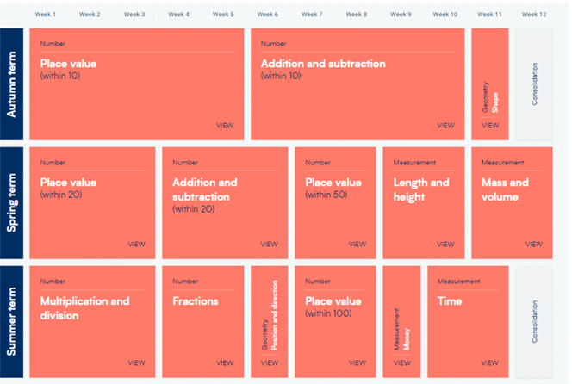
White Rose Maths Overview Year 2
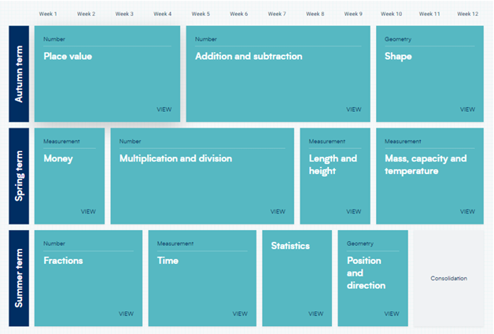

White Rose Maths Overview Year 3
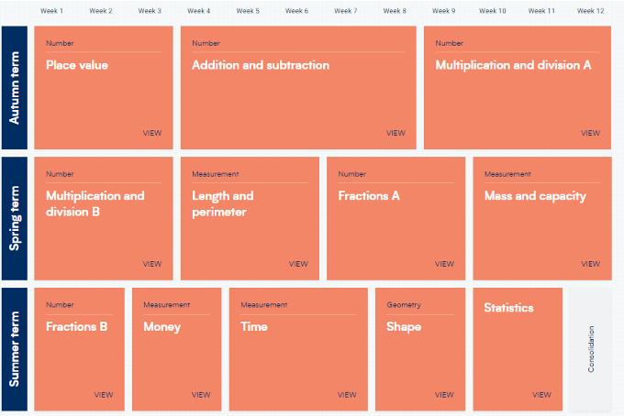
White Rose Maths Overview Year 4
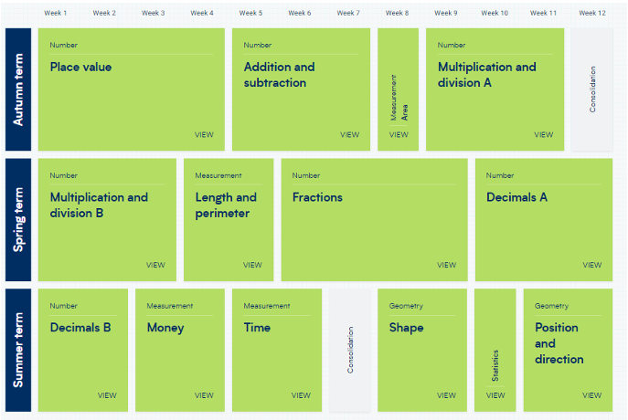
White Rose Maths Overview Year 5
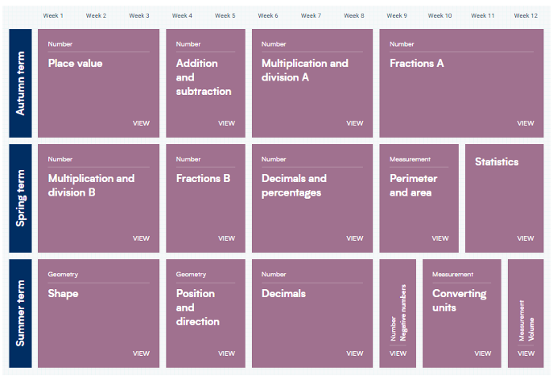
White Rose Maths Overview Year 6


