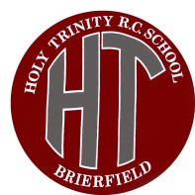
Holy Trinity R.C Primary School
British Values Policy

“To go forward together in Christ, respecting our neighbour and striving for excellence”

Promoting British Values at Holy Trinity R.C Primary School
Schools must now promote British values. Advice from the Department for Education is to do so through spiritual, moral, social and cultural development (SMSC.)
At Holy Trinity R.C Primary School we recognise the importance of promoting these values and ensure we take advantage of any possible teaching and learning opportunities linked to them, including continued professional development.
Holy Trinity R.C Primary School is a Catholic school and our mission statement supports our ethos of togetherness and respect in a democratic society.
At Holy Trinity R.C Primary School we agree to:
- Enable students to develop their self-knowledge, self-esteem and self-confidence.
- Enable students to distinguish right from wrong and to respect the civil and criminal law of England.
- Encourage students to accept responsibility for their behaviour, show initiative, and to understand how they can contribute positively to the lives of those living and working in the locality of the school and more widely in society.
- Enable students to acquire a broad general knowledge of and respect for public institutions and services in England.
- Further tolerance and harmony between different cultural traditions by enabling students to acquire an appreciation for and respect for their own and other cultures.
- Encourage respect for other people.
- Encourage respect for democracy and support for participation in the democratic processes, including respect for the basis on which the law is made and applied in England.
- Encourage respect for other people.
At Holy Trinity R.C Primary School we teach these values regularly through a range of activities, introducing and incorporating them through our R.E. and PSHE Curriculum, whilst also including further opportunities to develop other aspects through various subjects, topics or themes. These opportunities are enhanced through our social and emotional aspects of learning that lay the foundations for mutual respect and tolerance in a multi-cultural society.
We actively celebrate diversity, disability and equal opportunities by working in unison with other schools and community organisations. We encourage community cohesion and visitors to the school who promote British Values.

Democracy
Democracy is embedded at the school. Pupils are always listened to by adults and are taught to listen carefully and with concern to each other, respecting the right of every individual to have their opinions and voices heard. Pupils also have the opportunity to air their opinions and ideas through the different councils we have in school and pupil voice which is regularly carried out by members of staff. The elections of the head girl, head boy and their deputies, school council, and eco warriors are based solely on pupil votes, reflecting our British electoral system and demonstrating democracy in action. The children regularly have meetings and take an active role in trying to make the school a better place.
The Rule of Law
The importance of laws whether they are those that govern the class, the school or the country, are consistently reinforced. Our school has ‘Golden Rules’, which are deeply embedded in our work every day. Each class also discusses and sets its own rules that are clearly understood by all and seen to be necessary to ensure that every class member is able to learn in a safe and ordered environment. Our pupils are taught the value and reasons behind laws, that they govern and protect us, the responsibilities that this involves and the consequences when laws are broken.
Individual Liberty
Within school, pupils are actively encouraged to make choices, knowing that they are in a safe and supportive environment. As a school we educate and provide boundaries for our pupils to make choices safely, through the provision of a safe environment and an empowering education. Our pupils are encouraged to know, understand and exercise their rights and personal freedoms and are advised how to exercise these safely; examples of this can be clearly seen in our e-safety and PSHE. lessons. Whether it is through choice of challenge; of how they record; of participation in our numerous extra-curricular activities; our pupils are given the freedom to make choices.
Mutual Respect
Respect is one of the core values of our school as can be seen on our school mission statement ‘“To go forward together in Christ, respecting our neighbour and striving for excellence.” The pupils know and understand that it is expected and imperative that respect is shown to everyone, whatever differences we may have and to everything, however big or small. The core value of respect at Holy Trinity R.C Primary school underpins our work every day both in and out of the classroom.
Tolerance of Those with Different Faiths And Beliefs
Our core value of respect ensures tolerance of those who have different faiths and beliefs. Holy Trinity R.C Primary school enhances pupils understanding of different faiths and beliefs through religious education studies; PSHE work, welcoming visitors from other schools that are not predominately white British and enjoying a depth of study during themed weeks. Each class covers a different religion in R.E each year so children have good knowledge and understanding about the different faiths and traditions across the world. We have very close links with Building Bridges. Through this our pupils gain an enhanced understanding of their place in a culturally diverse society.

The British Values are also embedded in our school values.
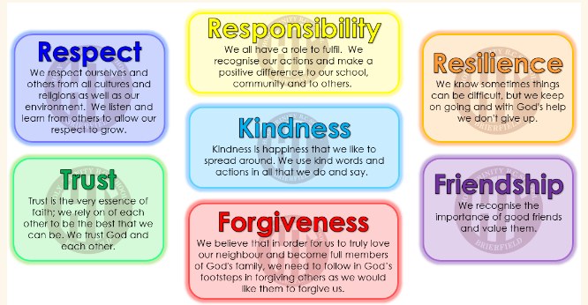
This policy is available on our school website. Reviewed: March 2024

