


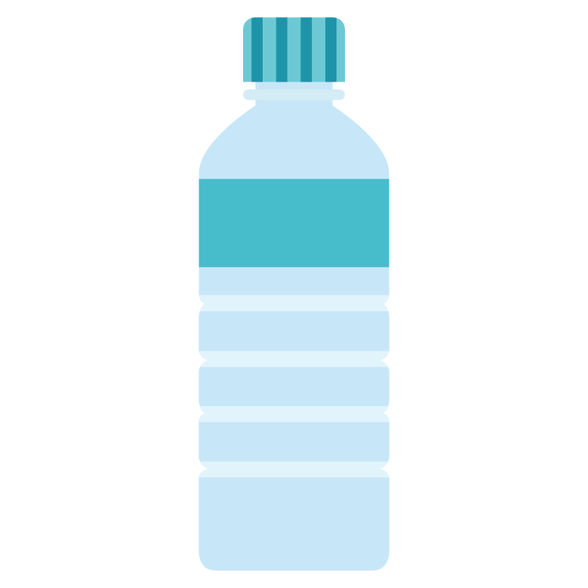


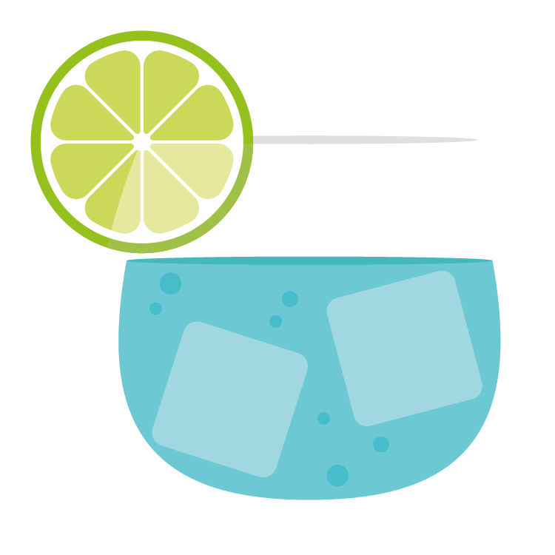
Preparing for School
Toilet Training
It is such an exciting time for children about to start their new school. Getting them prepared with independent toileting gives them a head start to their school life.

Signs to look out for
- Are they able to hold their wee for 1.5-2 hour’s?
- Showing signs of wanting to remove nappy
- Vocalising they have had a wee or poo
- Are they asking questions about toileting?
- Are they hiding when they are going for a poo in their nappy? Passing stools 4+ times weekly?
- Look for signs that they are needing to wee or poo. Are they squirming, jumping, squeezing their nappy or pulling funny faces?

Things you can do

- Plenty of fluids- This encourages the bladder to stretch and fill effectively. Restricting fluids is not going to reduce wet accidents it will in fact make them worse. Water, pale sugar free cordial and non-caffeinated drinks are recommended.
- Begin all nappy changes in the bathroom and keep all clean nappies, wipes and underwear there too.
- Place 2 sheets of kitchen towel (folded in half) inside their nappy. This enables them to feel that they are wet when they have had a wee.
- Be Prepared- Buy a step stool and toilet seat that they can independently use to get on and off the toilet. Buy plenty of underwear and pants easy to pull down (tracksuit bottoms/leggings) they will have accidents at first. Have potty’s available in each room for quick access.
- Be Brave- Get them into underwear as soon as possible. Pull ups are the same as nappies and do not allow the child to feel wet.
- Practice getting on and off the seat while they have clothing on then gradually remove clothing to the knees. They do not have to do something every time, we want them to feel comfortable sitting on the toilet. Praise after every time they sit on the toilet even if they haven’t done anything.
- Sit with them and sing songs, read stories and blow bubbles or tissue paper. Blowing helps relax the bowels and aids in passing stools along with a healthy diet of fibre, fruit and vegetables to keep our gut healthy.
- Use a regular toilet routine. Encourage to sit on the toilet 20 minutes after meals. This is when the digestive system wakes up and it is more likely for you to poo.
- Take them to the toilet with you and allow them to see. Talk about what you are doing. This reduces fear and allows them to feel more comfortable in using the toilet as they see you doing it.
- Take them to buy their own potty, underwear, step and toilet seat. They may like to decorate their potty with stickers too! Some children may prefer to use the toilet straight away instead of the potty. This is ok too.
- If they have used the potty, take them with you to dispose of the contents down the toilet. This will allow them to understand this is where the wee and poo goes.

Reward*Reward*Reward

Positive praise will help encourage your child to keep trying.

Useful links:

https://www.youtube.com/watch?v=DppqACJL0pc

https://play.google.com/store/apps/details?id=uk.nhs.ntw.poogoestopooland&hl=en_GB&gl=US

https://www.eric.org.uk/Handlers/Download.ashx?IDMF=5f75ad7a-178c-4fc8-a7ab-95bd26895607

https://www.eric.org.uk/Handlers/Download.ashx?IDMF=9b1c4466-ef97-436f-ad8a-9d53ffddb6a9

We are here to help
Talk to your health visitor or school nurse if you require further support on
0300 247 0040






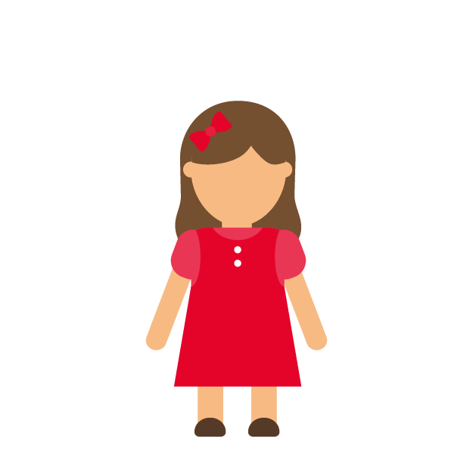
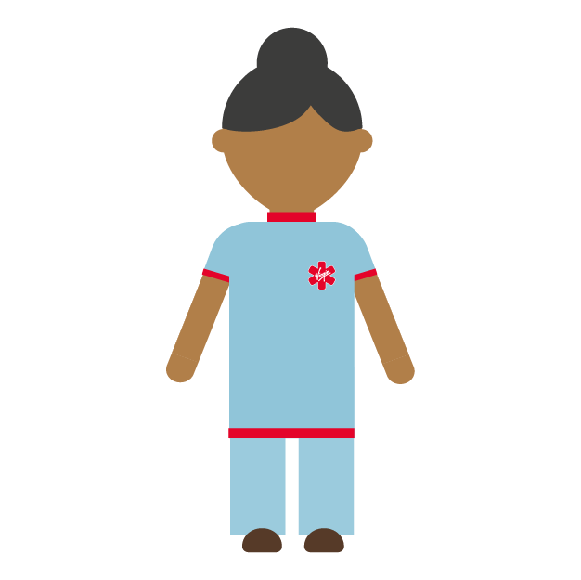

Are we ready for school?
We can help.

